## Problem 1 – Mountain King

Create a Web page (HTML5 + CSS3 + images + Bootstrap or SASS/LESS) that looks and behaves like the screenshots below:

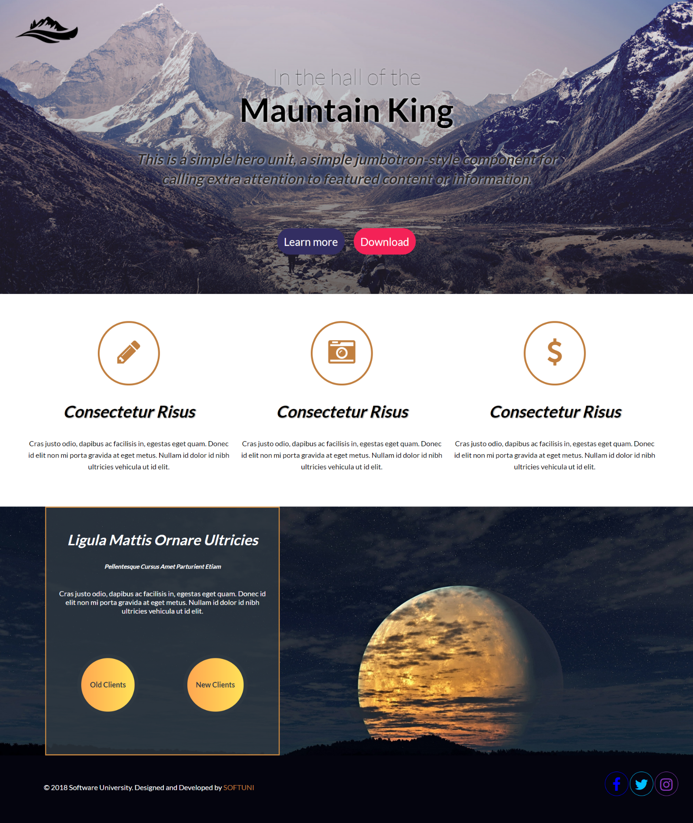

### Input

You are given the above screenshots + all required images + the texts on the site.

### Output

The output should be valid HTML5 + CSS3 + images that implement the above Web page.

### Constraints

* Use google font **Lato** - https://fonts.googleapis.com/css?family=**Lato**:100,300,400,700,900
* Use Font Awesome - https://maxcdn.bootstrapcdn.com/font-awesome/4.7.0/css/font-awesome.min.css
* The site should open correctly in the latest version of Chrome
* Pixel-perfect implementation is not required.